Political Socialization

Name
Institutional Affiliation
Course
Professor
Name

Political Socialization
Political socialization refers to the process in which individuals acquire values and opinions that defines their political stand. It’s the process through which citizens of a country understand and internalize how power is organized and arranged around the world (Publisher, 2016). Generally, the process of political socialization is a long term learning process that occurs both consciously and subconsciously. Over the years, there has been a great difference between how individuals are viewing politics and political power. There are several agents through which people socialize politically. For instance, the environment that surrounds individuals influences their political views in various ways. Also, people learn about politics through political parties (Political Socialization, n.d.). Political parties of a country can either reinforce the current norms in politics or introduce an entirely new political pattern.
According to the political scientist, people do not inherit political norms and culture. Instead, we learn the current culture and fit in. One advantage of political socialization is that it offers a political history that offers guidance in making decisions concerning a political move. Hence, people need to learn about the trends in the political world as it defines the behaviour they should portray in the political and economic environment they live in. Research indicates that a shift has occurred on the norms related to running political systems across the world. Today, citizens are empowered in such a way that they know what is right or wrong concerning politics. They have developed several ways to address the injustices in the political world. In museums, there are numerous galleries of past events, past leadership and people movements that caused havoc in a country, for example, Vietnam, Through the Eyes of Artists painting. The photo is a view of the Vietnam War era through Vietnamese eyes, the eyes of people on the receiving end of aggression (Cotter, 2019).
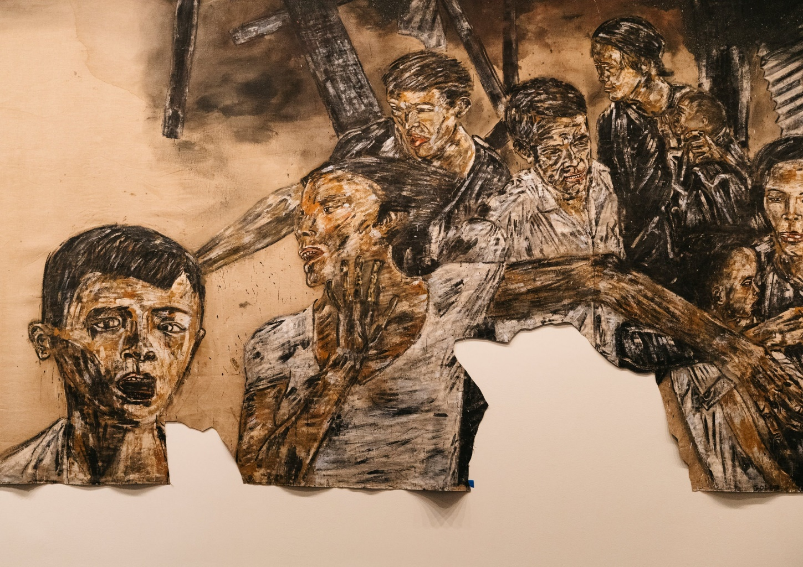A detail of Leon Golub’s “Vietnam II” (1973), at the Smithsonian American Art Museum.Credit...The Nancy Spero and Leon Golub Foundation for the Arts/Licensed by VAGA at Artists Rights Society (ARS), NY; Tate, London; Justin T. Gellerson for The New York Times

References
Cotter, H. (2019, April 4). Vietnam, Through the Eyes of Artists. The New York Times. https://www.nytimes.com/2019/04/04/arts/design/vietnam-war-american-art-review-smithsonian.html
Political Socialization. (n.d.). Retrieved August 5, 2020, from https://saylordotorg.github.io/text_american-government-and-politics-in-the-information-age/s10-02-political-socialization.html
Publisher, A. removed at request of original. (2016). 6.2 Political Socialization. In American Government and Politics in the Information Age. University of Minnesota Libraries Publishing edition, 2016. This edition adapted from a work originally produced in 2011 by a publisher who has requested that it not receive attribution. https://open.lib.umn.edu/americangovernment/chapter/6-2-political-socialization/.

